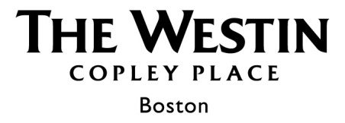
Exhibitor Order Form

PLEASE NOTE: Your order will NOT be confirmed until Credit Card information has been submitted via our
secure payment website. The link to this website will be sent to you via email once this form is received.

Please return this form to your Meeting and Event Manager:
Name: Maggie Lopez
E-mail: maggie.lopez@westin.com

Conference Information |  | Payment Information
Conference Name: American Literature Association |  | Contact Name:
Company Name: |  | Email:
Event Dates: |  | Phone Number:
Booth Number: |  | Billing Address:
On-Site Contact: |  | Billing Address:
Phone: | Email: | Billing Address:

Weight | Inbound & Outbound | Quantity | Weight | Storage Fee | Quantity
0 – 0.9 lbs | $5.00 |  | 0 – 10.0 lbs | $5.00
1.0 – 10.0 lbs | $15.00 |  | 10.01 – 30.0 lbs | $10.00
10.01 – 20.0 lbs | $20.00 |  | 30.01 – 60.0 lbs | $25.00
20.01 – 30.0 lbs | $30.00 |  | Pallets & Crates | $75.00
30.01 – 40.0 lbs | $40.00 |  | Please schedule your shipment to arrive at the hotel (2)-(3) days prior to the event/arrival start date to avoid additional storage fees. Use only the name of the recipient who will be on-site to receive and sign for your package(s).  *Due to limited storage space, we will assess the above fees after (5) days of arrival.
40.01 – 60.0 lbs | $50.00
Over 60.0 lbs | $75.00 | 1
Pallets & Crates | $150.00 and $1/lb over 300 lbs

SHIPPING INSTRUCTIONS
To ensure proper delivery, please follow the methods listed below to eliminate any package routing delays. Release signatures are captured at the time of any deliveries for our recipients. All packages will be applied an inbound receiving fee upon their arrival. These fees are applied in addition to your standard shipping rates. The inbound fees include the delivery charge to the Meeting/Guest room. Please do not ship any items to the attention of the Meeting & Events Manager unless the item(s) are specifically for their use as this could cause a delay in the package delivery.

PACKAGE LABELING STANDARD:
The Westin Copley Place Hotel
(Recipient Full Name) (Recipient Cell Number)
10 Huntington Avenue
Boston, MA 02116
(American Literature Association Conference May 2023)

